Azure to AWS VM migration:
AWS Application Migration Service:
Highlevel
- Install Agent
Install AWS Replication Agent on your source servers (manual or unattended installation). No reboot required.
- Replicate to AWS
Application Migration Service automatically replicates entire servers, including operating system, applications, data, and configurations.
- Perform tests
Use the Application Migration Service console to perform non-disruptive tests in AWS prior to initiating a cutover.
- Execute cutover
When you are ready, use the Application Migration Service console to execute a successful cutover. Your servers are launched on AWS within minutes

Details in steps:
What is an Application Migration Service?
AWS Application Migration Service (MGN) is a highly automated lift-and-shift (rehost) solution that simplifies, expedites, and reduces the cost of migrating applications to AWS. It allows companies to lift and shift a large number of physical, virtual, or cloud servers without compatibility issues, performance disruption, or long cutover windows. MGN replicates source servers into your AWS account. When you’re ready, it automatically converts and launches your servers on AWS so you can quickly benefit from the cost savings, productivity, resilience, and agility of the Cloud. Once your applications are running on AWS, you can leverage AWS services and capabilities to quickly and easily re-platform or refactor those applications — which makes lift-and-shift a fast route to modernization.

Architecture diagram:
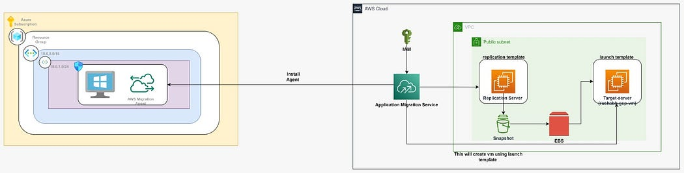

Steps to be followed for this Solution:

Step 1: Set Up the AWS Application Migration Service
Navigate to AWS Application Migration Service:
- Go to the AWS Application Migration Service (AWS MGN)
- Before we do the configuration, We’ll discuss what is the launch template and replication template.
Replication Template: A Replication Template defines how your source servers (on-premises or other cloud environments) should be replicated to AWS. It includes settings for the replication servers, such as the instance types, volume settings, and network configurations for the Replication Server. This server is responsible for creating snapshots and EBS volumes and replicating all your data into it.
Purpose and Why it’s Needed:
- Configuration Consistency: It ensures that the replication process is consistent across multiple servers by applying the same settings to all of them.
- Simplified Management: By using replication templates, you can streamline and standardize the replication settings for multiple servers, reducing manual configuration and errors.
- Optimization: You can tailor the replication settings to meet the performance and cost requirements of your migration.

Launch Template: A Launch Template specifies how the target instances in AWS should be configured when the replication is complete and the servers are launched. It includes instance type, network configurations, key pairs, and other settings necessary for the target instance launch.
Purpose and Why it’s Needed:
- Automated Instance Creation: It allows you to automate the creation of target instances based on predefined settings, ensuring that they are launched consistently and correctly.
- Flexibility and Customization: You can define different launch templates for different application requirements, providing flexibility to handle various types of applications and workloads.
- Efficiency: It streamlines the deployment process, allowing you to quickly and efficiently launch instances with the required configurations without manual intervention.
Step 2: Replication template and Launch template configuration:
- Create the Replication template and choose the desired instance type, volumes, subnet etc. for the Replication Server.
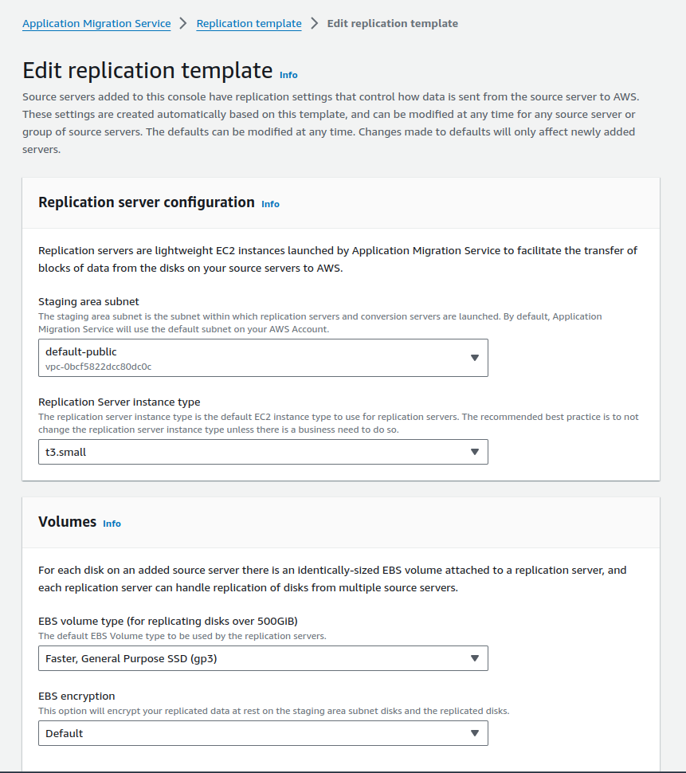
ReplicationTemplate
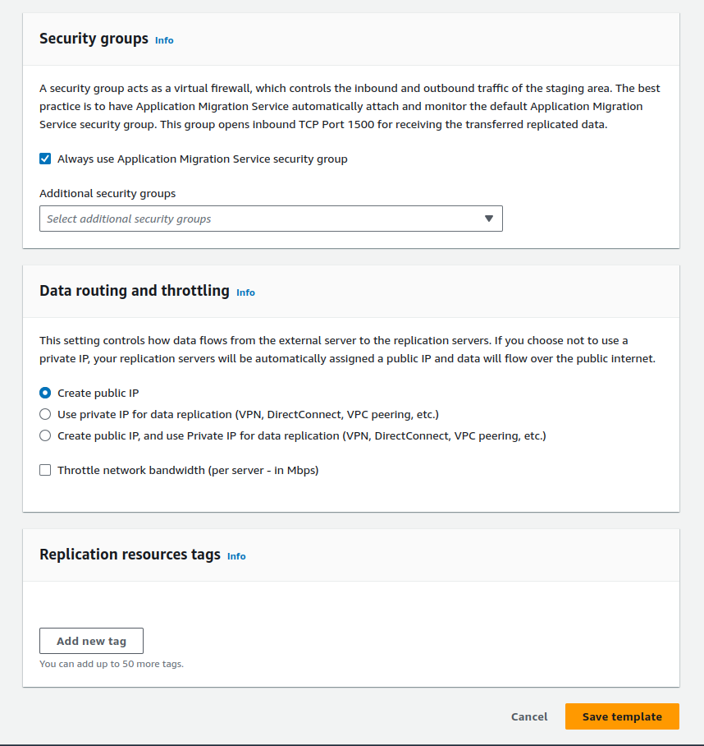
ReplicationTemplate2
- Create the Launch template and choose the desired instance type, volumes, subnet etc. for the Target Server.
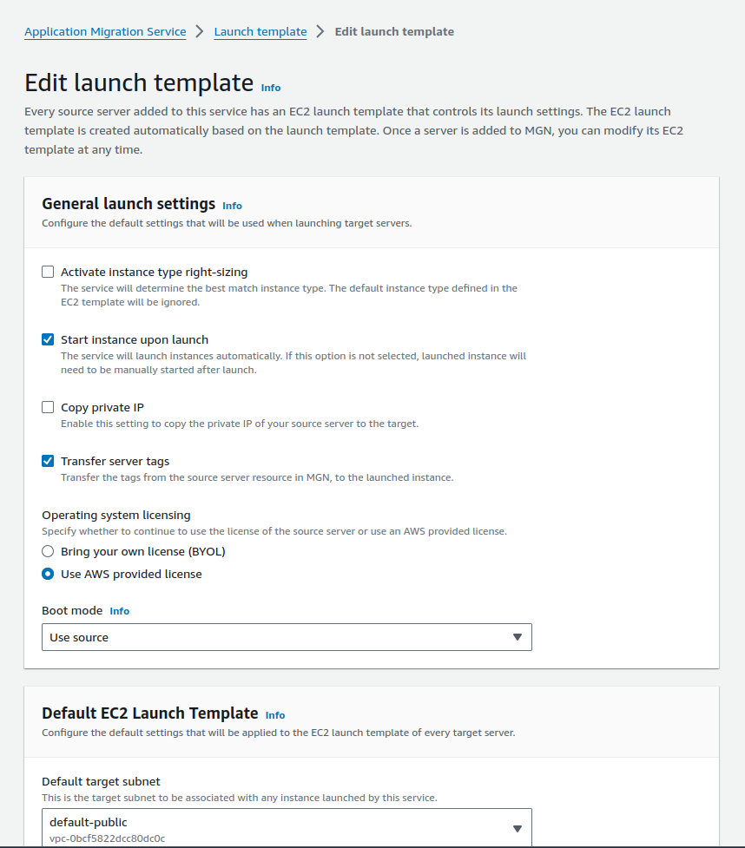
LaunchTemplate
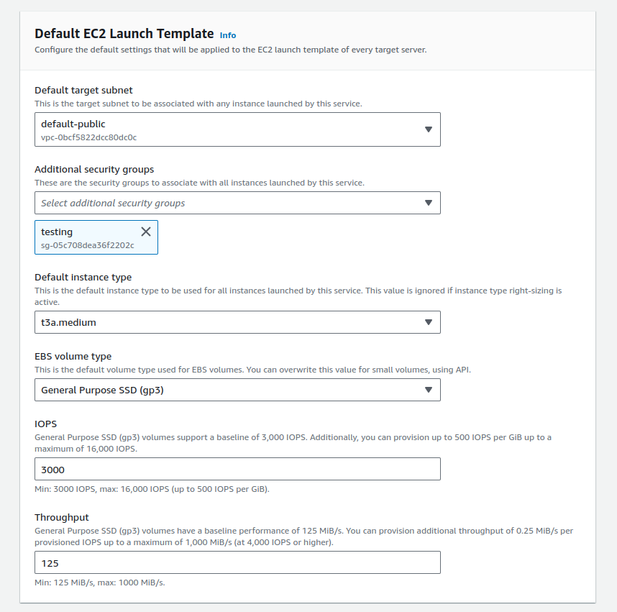
LaunchTemplate2
Step 3: Install the AWS Replication Agent on Your Azure VM
- Download the Replication Agent:
- Look for Source Servers in the AWS MGN console and Click on Add server.
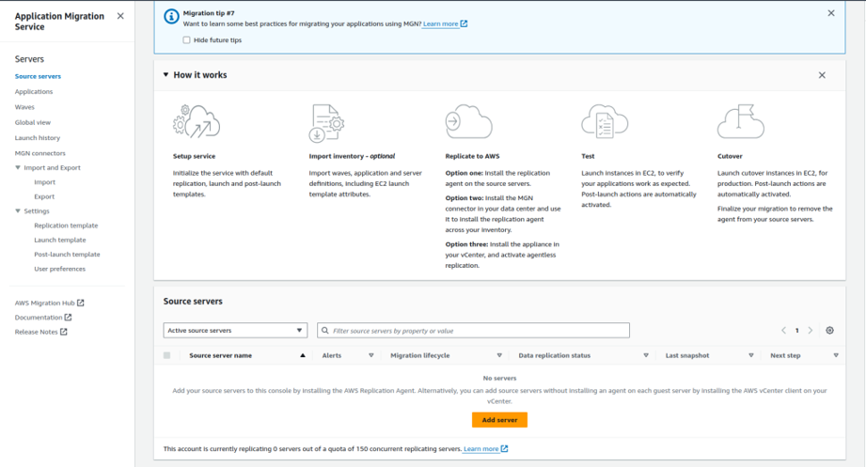
Add-server
- Select the operating system i.e Windows.
- Choose which disks to replicate, we’ll replicate all the disks for now.
- Create a new user with permission as AWSApplicationMigrationAgentInstallationPolicy and use the access and secret access key.
- IAM credentials
- In order to install the AWS Replication Agent, you must first generate the required AWS credentials by doing the following:
- Go to the AWS Identity and Access Management (IAM) console.
- Create a new IAM Role with the AWSApplicationMigrationAgentInstallationPolicy policy.
- Request temporary security credentials through AWS STS through the AssumeRole API.
- Using temporary credentials is best practice. However, specific use cases, such as agentless snapshot-based replications, require long-term credentials. In that case, you will need to create at least one IAM user with the proper permission policy.
- You will need to enter the credentials and you obtained into the agent installation prompt in order to begin the installation.
- Input the IAM access key ID, IAM secret access key, and Session token (only provided with temporary credentials) that you previously generated for AWS Replication Agent installation into the corresponding fields.
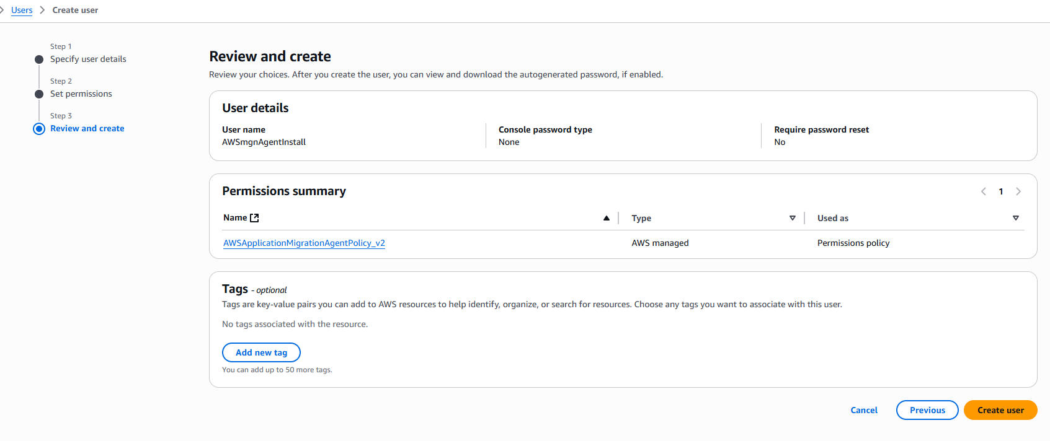
User: arn:aws:sts::210727069822:assumed-role/AWSReservedSSO_AWSAdministratorAccess_de167c505c770d9b/AMD@cloud.ga.gov
Action: iam:CreateUser
On resource(s): arn:aws:iam::210727069822:user/AWSmgnAgentInstall
Context: a service control policy explicitly denies the action
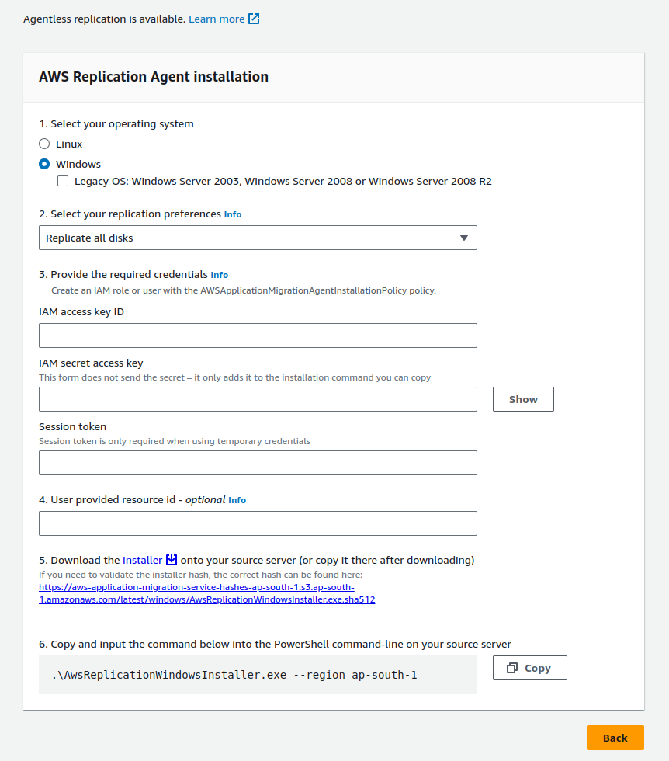
DownloadAgentInstaller
2. Install the Replication Agent:
- Right click on the Installer, copy the link address, and paste it on your Azure VM to download the agent installer.
- Run the downloaded installer and follow the on-screen instructions to install the replication agent.
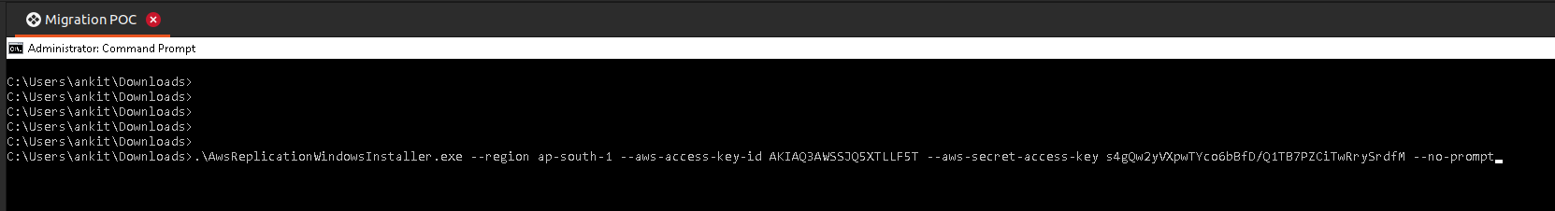
agent installation
Step 4: Verify Server Creation:
- In AWS Application Migration Service, a replication server will automatically be created.
- This server is responsible for creating snapshots and volumes of your source VM.
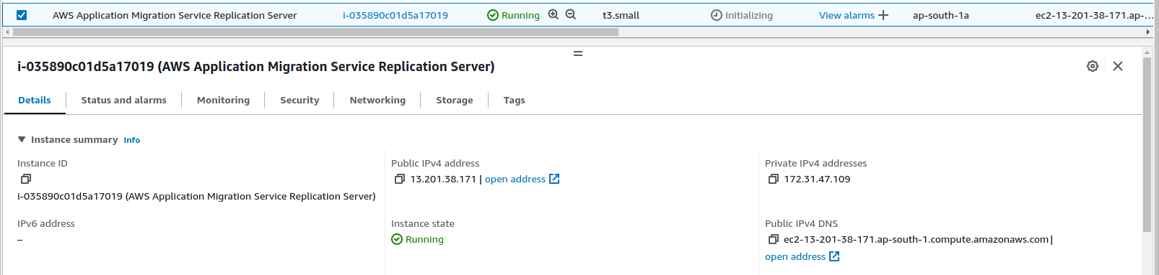
Replicationserver-auto
Step 5: Monitor Replication Progress
- Monitor the status of the replication job from the AWS MGN console.
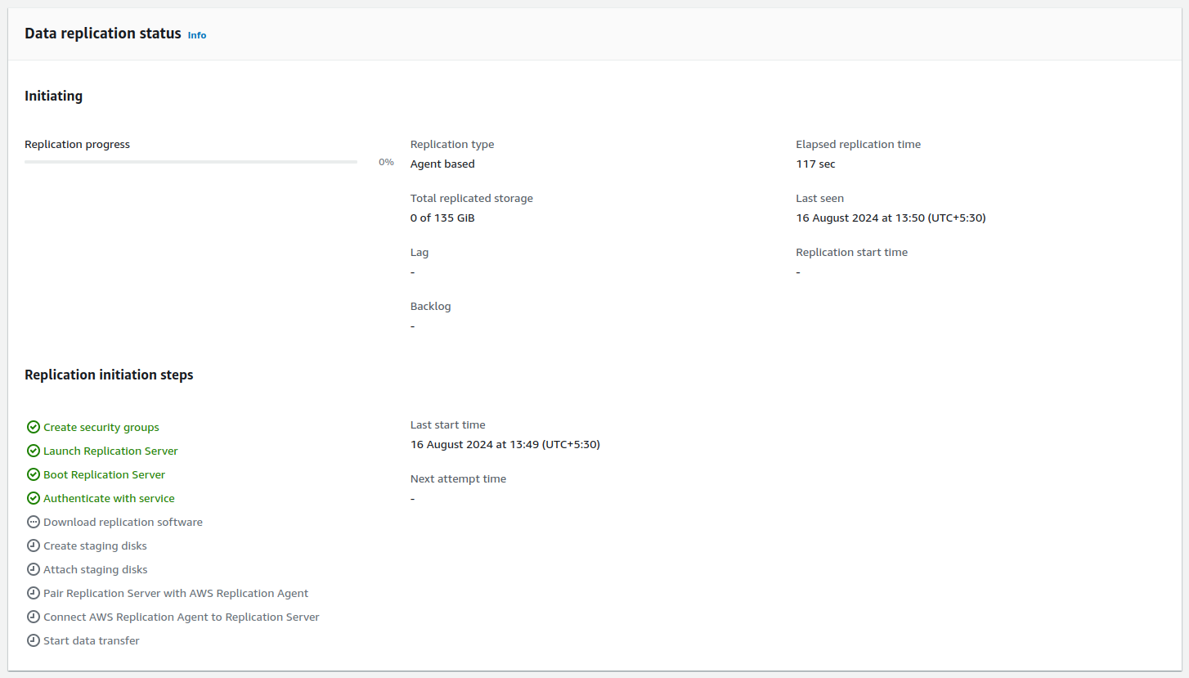
ReplicationStarted
Step 6: Launch and Test the Migrated VM
Launch test instances:
- After the replication progress completes to 100% then click on the Test and cutover option on the top right side of the console and Launch test instances.
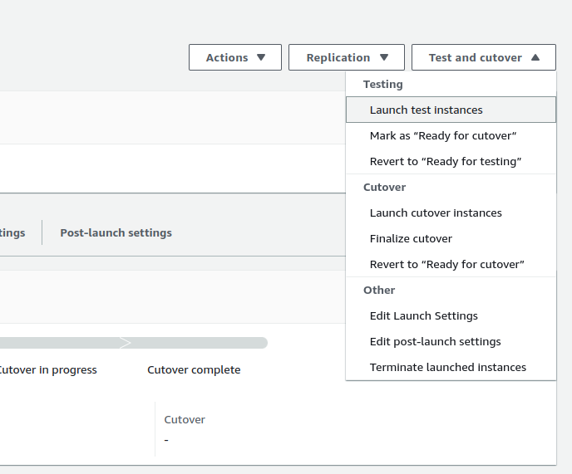
LaunchInstances-testandcutover
- You can see that an instance with the same name as that of Azure VM is created, and I will proceed to mark it as Ready for Cutover.
- I will proceed directly to the Cutover phase without testing the data. However, it is advisable to thoroughly test your data on a test VM, especially when working on a production server.
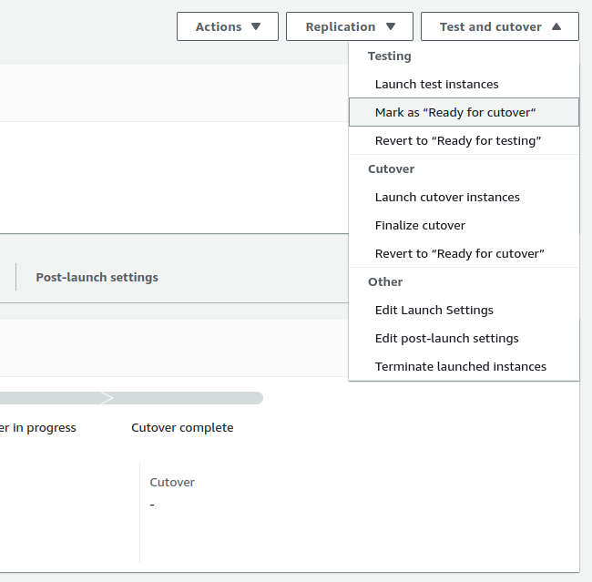
MarkAsReadyForCUtover
- After that click on Launch cutover instances in the Test and Cutover section to launch the final cutover instance.
- We can see our final cutover instance with the same name as Azure VM, which is machine5 in our case.
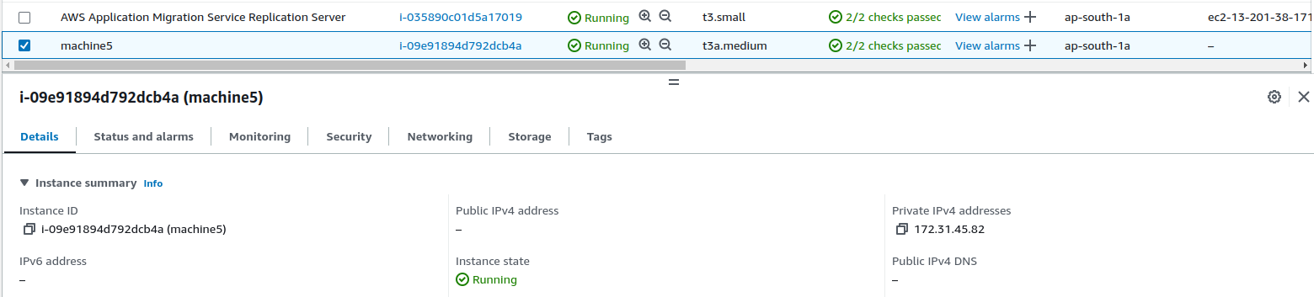
FinalCutoverInstance
Test the VM:
- After launching the instance, connect via RDP to verify that everything has been successfully replicated.
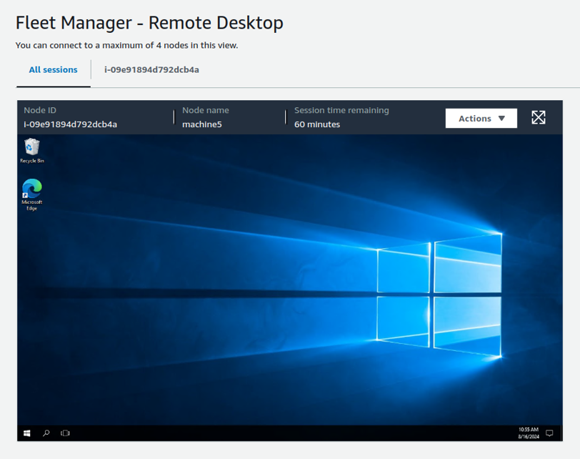
RDP-fleetmanager
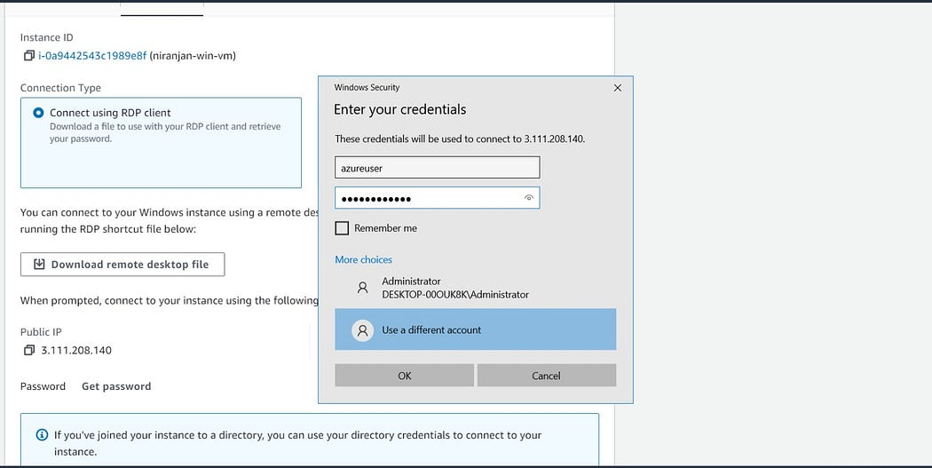
After logging in check your data that where you have stored. In my case I have stored my data in F: drive as shown below:
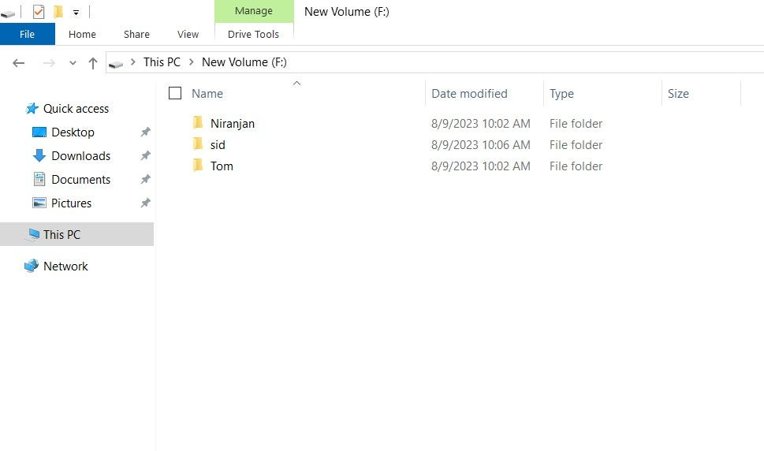
After that go to Aws virtual machine and Copy pubic IP of your VM and Access your apps content as shown below:
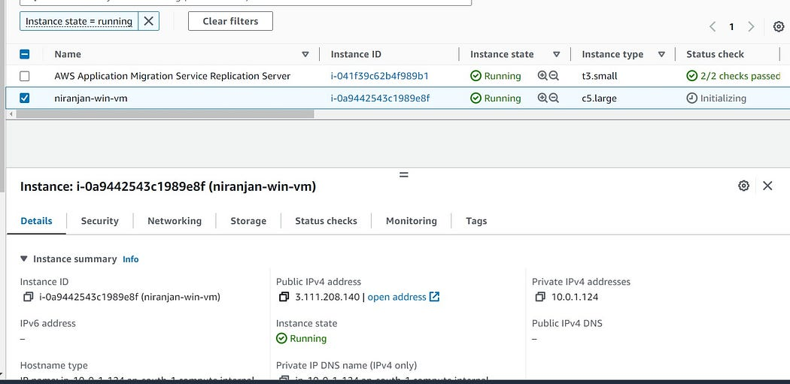

Now the migration of data from Azure to AWS is successful.
Ref: https://aws.amazon.com/blogs/compute/migrating-azure-vm-to-aws-using-aws-sms-connector-for-azure/

